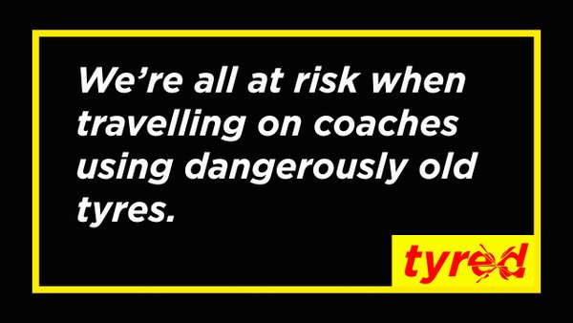

Schools’ Tyred Pledge

We understand that tyres over 10 years old are not safe to use.
We pledge to make our children safer by:
- Ensuring that all companies used to transport our children follow the Government recommendations of having tyres less than 10 years old.
- Promoting the ‘safe tyre’ message within our school.
- Enabling parents to check the age of their own tyres by providing information about how to read the DOT code.

Head teacher
School Council Leader
Student Representative

